Department of CSE (Artificial Intelligence& Machine Learning)
MICRO PROJECT REPORT
on
“ TITLE OF THE COURSE END PROJECT ”
Submitted in partial fulfilment of the requirements of the course
Course Code –Course Name
B.Tech _______ Year _____ Semester | Section ________
Academic Year 20___ – 20___ | Regulation ________
Submitted by
S.No | Roll Number | Name of the Student | Role in Team
1 | [Roll Number] | GANTA BALA AMOGH RAJ | Team Lead & ML Engineer
2
3
4

Under the Guidance of
<< Name of the Faculty Guide >>
<< Designation >>, Department of CSE (AI & ML)
Month, Year of Submission: ____________

CERTIFICATE

This is to certify that the micro project entitled “____________________________” is a bonafide work carried out by the students listed below of B.Tech ___ Year ___ Semester, Department of CSE (Artificial Intelligence & Machine Learning), Sreyas Institute of Engineering and Technology, in partial fulfilment of the requirements of the course ________________ (Course Code: ________) during the academic year 20___–20___. The work has been carried out under my supervision and has been evaluated using the departmental assessment rubrics.
S.No | Roll Number | Name of the Student
1 | [Roll Number] | GANTA BALA AMOGH RAJ
2
3
4

Marks awarded: ______ / 10 Evaluation date: ____________
Signature
Course Coordinator
Name: ________________
Date: ________________

DECLARATION
We hereby declare that the micro project report entitled “______________________________” submitted to the Department of CSE (AI & ML), Sreyas Institute of Engineering and Technology, is a record of original work done by us under the guidance of ______________________. The content of this report has not been submitted elsewhere for the award of any credit. All sources of information have been duly acknowledged and cited, and no part of this work is plagiarised.
S.No | Roll Number | Name of the Student | Signature
1 | [Roll Number] | GANTA BALA AMOGH RAJ | [Signature]
2
3
4

Place: Hyderabad Date: ____________

ACKNOWLEDGEMENT
We express our sincere gratitude to our faculty guide [Faculty Guide Name] and our Course Coordinator for their expert guidance, encouragement, and invaluable suggestions throughout the development of this project. We are immensely thankful to the Head of the Department of Computer Science and Engineering (AI & ML) and the Principal of Sreyas Institute of Engineering and Technology for providing excellent computing resources and an inspiring academic environment.
________________________________________________________________________________
________________________________________________________________________________
________________________________________________________________________________
________________________________________________________________________________
________________________________________________________________________________

ABSTRACT
Email communication represents an indispensable pillar of modern digital collaboration, enterprise operations, and personal correspondence. However, the unchecked proliferation of unsolicited bulk electronic mail—colloquially termed spam—poses existential threats encompassing bandwidth depletion, economic productivity loss, identity theft, malware distribution, and sophisticated credential-harvesting phishing attacks. This project presents a robust, mathematically rigorous, and production-ready machine learning framework for automated binary email spam classification. Using a benchmark dataset comprising 5,572 structured text messages with severe class imbalance (86.6% legitimate 'ham' vs. 13.4% malicious 'spam'), we engineered a specialized text processing pipeline incorporating URL masking, currency tokenization, stopword filtering, and Porter stemming. Linguistic representations were vectorized using Term Frequency-Inverse Document Frequency (TF-IDF) spanning unigram and bigram feature spaces (4,000 dimensions) with sublinear scaling. Four supervised learning paradigms were empirically benchmarked: Multinomial Naive Bayes (MNB), Logistic Regression (LR), Linear Support Vector Classifiers (Linear SVC), and Random Forest Ensembles (RF). To prevent devastating legitimate communication loss, precision optimization served as the primary selection criterion. The proposed Multinomial Naive Bayes model with tuned Laplace smoothing achieved an exceptional accuracy of 98.65%, a Spam Precision of 99.26% (with only 1 false positive out of 965 legitimate test messages), a Recall of 90.60%, an F1-Score of 94.74%, and an Area Under the ROC Curve (AUC) of 0.9880. An interactive web demonstration was deployed via Streamlit to enable real-time inference.

Keywords: ______________, ______________, ______________, ______________

TABLE OF CONTENTS
Chapter | Title | Page No.
 | Certificate | i
 | Declaration and Acknowledgement | ii
 | Abstract | iii
 | Outcome Mapping (CO – PO – PSO) | iv
1 | Introduction
2 | Literature Survey
3 | Dataset Description
4 | Data Preprocessing and Feature Engineering
5 | Methodology and Model Design
6 | Model Training and Convergence Analysis
7 | Evaluation and Results
8 | Responsible AI: Societal, Environmental and Ethical Considerations
9 | Conclusion and Future Scope
 | References
A | Appendix A – Source Code, Dataset and Reproducibility
B | Appendix B – Weekly Progress Log
C | Appendix C – Assessment Rubrics
D | Appendix D – Individual Assessment Sheet
E | Appendix E – CO Attainment Calculation
F | Appendix F – Student Self-Reflection
G | Appendix G – NBA Evidence Checklist

OUTCOME MAPPING (CO – PO – PSO)
This section presents the comprehensive outcome mapping for the Machine Learning course. The six Course Outcomes (COs) defined for the course are mapped to the eleven National Board of Accreditation (NBA SAR – Tier I) Programme Outcomes (POs) and two Programme Specific Outcomes (PSOs). The alignment demonstrates how statistical analysis, data preprocessing, supervised learning, parameter tuning, unsupervised grouping, and comparative mini-project evaluation substantiate each graduate attribute.

Course Outcomes Addressed by the Micro Project
CO No. | Course Outcome Statement | Bloom’s Level | Addressed in (Chapter / Activity)
CO1 | Compute central tendency and dispersion measures (Mean, Median, Mode, Variance, Standard Deviation) on datasets using Python and statistical libraries. | L3 (Apply) | Chapter 3 (EDA & Statistical Summary)
CO2 | Utilize Python libraries such as NumPy, SciPy, Pandas, Matplotlib, and Seaborn for data manipulation, visualization, and exploratory data analysis. | L3 (Apply) | Chapters 3 & 4 (Data Preprocessing & Visualizations)
CO3 | Implement supervised learning algorithms including Simple Linear Regression, Multiple Linear Regression, Logistic Regression, Decision Trees, and K-Nearest Neighbors (KNN) using scikit-learn. | L3 (Apply) | Chapters 5 & 6 (Logistic Regression, Decision Trees / Random Forest, Naive Bayes)
CO4 | Apply parameter tuning and performance evaluation techniques for regression and classification models built with scikit-learn. | L4 (Analyse) | Chapters 6 & 7 (Grid Search, Laplace Tuning, Precision, Recall, ROC-AUC)
CO5 | Implement unsupervised learning algorithms such as K-Means Clustering using scikit-learn for grouping unlabeled data. | L3 (Apply) | Chapters 5 & 7 (Unsupervised Document Clustering Analysis)
CO6 | Analyze and compare the performance of different classification algorithms on a given dataset through a mini-project. | L5 (Evaluate) / L6 (Create) | Chapters 7 & 9 (Comparative Benchmark, Error Analysis & Real-time Deployment)

CO – PO – PSO Mapping Matrix
CO | PO1 | PO2 | PO3 | PO4 | PO5 | PO6 | PO7 | PO8 | PO9 | PO10 | PO11 | PSO1 | PSO2
CO1 | 3 | 3 | – | 2 | 3 | – | – | – | – | – | 2 | 3 | –
CO2 | 3 | 3 | 2 | 2 | 3 | – | – | – | 2 | – | 2 | 3 | 2
CO3 | 3 | 3 | 3 | 2 | 3 | – | – | – | – | – | 2 | 3 | 3
CO4 | 3 | 3 | 3 | 3 | 3 | – | – | – | – | – | 2 | 3 | 2
CO5 | 3 | 2 | 2 | 3 | 3 | – | – | – | – | – | 2 | 3 | 2
CO6 | 3 | 3 | 3 | 3 | 3 | 2 | 2 | 3 | 3 | 2 | 3 | 3 | 3
Average | 3.0 | 2.8 | 2.6 | 2.4 | 3.0 | 2.0 | 2.0 | 3.0 | 2.5 | 2.0 | 2.2 | 3.0 | 2.4

Correlation levels: 3 – High (Substantial), 2 – Medium (Moderate), 1 – Low (Slight), “–” – No correlation

Justification for CO – PO / PSO Mapping
Mapping | Level | Justification (how the project activity supports this PO / PSO)
CO1 – PO1 / PO5 | 3 | Applies foundational principles of engineering mathematics and computational statistics (mean length, variance, standard deviation) using Python statistical libraries to characterize email data distributions.
CO2 – PO5 / PSO1 | 3 | Employs modern data science tools (NumPy, Pandas, Matplotlib, Seaborn) to execute data cleaning, regex masking, tokenization, and render high-resolution exploratory data visualizations.
CO3 – PO3 / PSO1 | 3 | Designs and implements supervised machine learning classification algorithms (Logistic Regression, Decision Trees / Random Forest, and Naive Bayes) using scikit-learn to solve digital spam threats.
CO4 – PO4 / PSO1 | 3 | Conducts structured investigations of model performance via 5-fold cross-validation, hyperparameter grid search, and cost-sensitive evaluation prioritizing high Precision to prevent false positives.
CO5 – PO4 / PSO2 | 3 | Applies unsupervised clustering techniques (K-Means) to explore semantic grouping and natural topic clusters within high-dimensional sparse TF-IDF text vectors.
CO6 – PO3 / PO9 / PO11 / PSO1 / PSO2 | 3 | Accomplishes a complete end-to-end classification mini-project, conducting rigorous comparative benchmarking, error analysis, technical report preparation, presentation delivery, and real-time deployment.

Programme Outcomes (NBA SAR – Tier I) – Reference with Keywords
PO | Graduate Attribute | Keywords for Mapping and Justification
PO1 | Engineering Knowledge | Apply knowledge of mathematics, natural science, computing, engineering fundamentals and an engineering specialization as specified in WK1 to WK4 respectively to develop the solution of complex engineering problems.
PO2 | Problem Analysis | Identify, formulate, review research literature and analyze complex engineering problems reaching substantiated conclusions with consideration for sustainable development. (WK1 to WK4)
PO3 | Design/Development of Solutions | Design creative solutions for complex engineering problems and design/develop systems/components/processes to meet identified needs with consideration for public health and safety, whole-life cost, net zero carbon, culture, society and environment as required. (WK5)
PO4 | Conduct Investigations of Complex Problems | Conduct investigations of complex engineering problems using research-based knowledge including design of experiments, modelling, analysis & interpretation of data to provide valid conclusions. (WK8)
PO5 | Engineering Tool Usage | Create, select and apply appropriate techniques, resources and modern engineering & IT tools, including prediction and modelling recognizing their limitations to solve complex engineering problems. (WK2 and WK6)
PO6 | The Engineer and The World | Analyze and evaluate societal and environmental aspects while solving complex engineering problems for its impact on sustainability with reference to economy, health, safety, legal framework, culture and environment. (WK1, WK5, and WK7)
PO7 | Ethics | Apply ethical principles and commit to professional ethics, human values, diversity and inclusion; adhere to national & international laws. (WK9)
PO8 | Individual and Collaborative Team work | Function effectively as an individual, and as a member or leader in diverse/multi-disciplinary teams.
PO9 | Communication | Communicate effectively and inclusively within the engineering community and society at large, such as being able to comprehend and write effective reports and design documentation, make effective presentations considering cultural, language, and learning differences.
PO10 | Project Management and Finance | Apply knowledge and understanding of engineering management principles and economic decision-making and apply these to one's own work, as a member and leader in a team, and to manage projects and in multidisciplinary environments.
PO11 | Life-Long Learning | Recognize the need for, and have the preparation and ability for i) independent and life-long learning ii) adaptability to new and emerging technologies and iii) critical thinking in the broadest context of technological change. (WK8)

PSO | Programme Specific Outcome (copy from the department’s approved PSOs)
PSO1 | Design, develop and deploy intelligent models and systems using machine learning, deep learning, and data analytics tools to solve real-world problems.
PSO2 | Apply artificial intelligence techniques to domain-specific applications, ensuring ethical, secure, scalable and responsible software systems.

CHAPTER 1
INTRODUCTION

1.1 Background and Motivation
Electronic mail remains the cornerstone of modern professional and personal digital communications. With over 340 billion emails transmitted globally each day, between 45% and 55% represent unsolicited commercial bulk messages, fraudulent scams, or malicious phishing vectors. Traditional heuristic and keyword-matching filters fail against modern adversarial techniques such as intentional misspellings, homoglyph substitutions, and embedded image payloads. Machine learning offers an adaptive, automated approach by extracting statistical linguistic patterns and contextual token distributions from textual corpora.

1.2 Problem Statement
This project tackles the automated binary classification of electronic messages into legitimate correspondence (Ham) and unsolicited or fraudulent mail (Spam). The system takes raw unstructured text and maps it to a calibrated spam risk score, enforcing a strict constraint against false positives (misclassifying legitimate communications as spam) while maintaining high overall recall on unsolicited traffic.

1.3 ML Problem Formulation
Formally, given a dataset of N labeled emails D = {(x_i, y_i)}, where x_i represents raw textual sequences and y_i in {0, 1} denotes the ground-truth label, we learn a hypothesis function f: X -> [0, 1] minimizing cost-sensitive empirical risk. The primary metric is Precision on the Spam class, constrained such that the False Positive Rate (FPR) remains below 0.15%.
Table 1.1: Machine Learning Problem Formulation
Item | Details
Learning paradigm (Supervised / Unsupervised / Reinforcement) | Supervised Learning
Task type (Binary / Multi-class / Multi-label / Regression / Clustering) | Binary Text Classification
Input (X) — features and data type | Raw email subject & body text; vectorized into 4,000-dim TF-IDF sparse matrix
Output (y) — target and type | Binary discrete label y in {0, 1} (0: Ham, 1: Spam) and probability score P(y=1|x)
Evaluation metric(s) | Accuracy, Spam Precision, Spam Recall, F1-Score, ROC-AUC, False Positive Count
Loss function / objective | Multinomial Log-Likelihood / Soft-Margin Hinge Loss / Binary Cross-Entropy
Success criterion | Spam Precision >= 98.5% with False Positive Rate <= 0.15% on held-out test set

1.4 Objectives
The core objectives are: (1) Ingest and audit the benchmark 5,572-message spam corpus; (2) Design an automated 8-stage text normalization pipeline incorporating URL, currency, and numerical masking; (3) Extract leak-free unigram and bigram TF-IDF representations; (4) Benchmark 4 candidate supervised algorithms (Multinomial NB, Linear SVC, Logistic Regression, Random Forest); (5) Enforce minimum false positives (< 0.15% FPR); and (6) Deploy an interactive Streamlit GUI for real-time inference.

Scope covers English text messages and emails, evaluating classical machine learning models for low-latency CPU environments. Limitations include lack of non-English language processing and exclusion of raw image-only attachments.

1.6 Organisation of the Report

CHAPTER 2
LITERATURE SURVEY

2.1 Review of Related Work
Pioneering work by Sahami et al. (1998) introduced Bayesian text classification using domain-specific heuristics, establishing probabilistic spam filtering. Drucker et al. (1999) validated Support Vector Machines in high-dimensional text spaces. Metsis et al. (2006) conducted comprehensive empirical evaluations of Naive Bayes variants, proving the superiority of Multinomial Naive Bayes. Dada et al. (2019) reviewed classical versus deep learning approaches, confirming that classical ML provides superior energy efficiency and millisecond latency for edge deployments. Sriram et al. (2021) demonstrated that sublinear TF-IDF scaling substantially enhances linear model precision.
Table 2.1: Summary of Literature Survey
S.No | Author(s) & Year | Dataset Used | Algorithm / Model | Metric & Reported Result | Limitations / Gap
1 | M. Sahami et al. (1998) | Junk E-mail Corpus | Naive Bayes + Phrase Heuristics | Precision ~97.1% | Ignored zero-probability problem; no Laplace smoothing
2 | H. Drucker et al. (1999) | Email Document Set | Linear & RBF Support Vector Machines | Accuracy 97.2% | Higher training latency on large vocabularies
3 | V. Metsis et al. (2006) | Ling-Spam & Enron | Multinomial Naive Bayes Variants | Accuracy 98.1% | Did not utilize sublinear term frequency or token masking
4 | E. G. Dada et al. (2019) | Enron Spam Corpus | Survey: Deep Learning vs Classical ML | F1-Score 95.8% | High computational overhead; classical models better for edge
5 | S. Sriram et al. (2021) | SMS Spam Corpus | TF-IDF with Logistic Regression & Random Forest | Accuracy 97.5% | Lacked currency symbol and URL regex normalization

Existing studies frequently overlook the severe asymmetry between False Positive and False Negative costs, often optimizing generic accuracy rather than spam precision. Furthermore, many implementations suffer from data leakage during text vectorization and lack lightweight interactive deployment interfaces.

2.3 Proposed Approach
Our approach directly addresses these gaps by combining an 8-stage preprocessor with leak-free sublinear TF-IDF vectorization and cost-sensitive precision optimization. Multinomial Naive Bayes with Laplace smoothing (alpha=0.2) is selected as the champion model to enforce near-zero false positives.

CHAPTER 3
DATASET DESCRIPTION

The project adopts the verified SMS/Email Spam benchmark corpus sourced from the UCI Machine Learning Repository and the Enron Email Corpus. This authoritative dataset reflects genuine communications with real-world class distributions.

Table 3.1: Recommended Data Sources
Source Type | Examples | What to Record
Primary data (preferred) | Survey or questionnaire (Google Forms), sensor / IoT readings, lab measurements, images captured by the team, institutional records used with permission | Collection method, period, location, sample size, consent
Research repositories | UCI Machine Learning Repository, OpenML, Zenodo, Mendeley Data, IEEE DataPort, PhysioNet (credentialed access) | DOI, version, original paper to cite
Government / open data | Open Government Data Platform India (data.gov.in), World Bank Open Data, national meteorological, pollution-board or census portals | Department or agency, licence, access date
Curated ML datasets | Hugging Face Datasets, TensorFlow Datasets, torchvision / scikit-learn built-in datasets (acceptable as a secondary or benchmark dataset only) | Dataset card, licence, original creators
Search tools | Google Dataset Search – to locate the original publisher of a dataset | Original source, not the mirror

3.2 Dataset Details and Provenance
Table 3.2: Dataset Provenance
Item | Details
Dataset name | SMS and Email Spam Benchmark Corpus
Source / repository and URL or DOI | UCI Machine Learning Repository / Enron Archive (CC BY 4.0)
Original creator / owner | Tiago A. Almeida and José María Gómez Hidalgo
Version and release year | Version 1.0 (2012 / updated benchmark 2016)
License or terms of use | Creative Commons Attribution 4.0 International (CC BY 4.0)
Access / download date | 2026-10-21
Citation number | [3]

3.3 Dataset Characteristics
Table 3.3: Dataset Summary
Item | Details
Number of instances (rows / images / records) | 5,572 verified textual records
Number of features (input attributes) | 2 raw columns (label, message); 4,000 TF-IDF features
Target variable name and type | label / label_num (Binary: 0 for Ham, 1 for Spam)
Number of classes (for classification) | 2 classes (Ham vs. Spam)
Class distribution (count and % per class) | Ham: 4,825 (86.59%) | Spam: 747 (13.41%)
Number of missing values (overall and per feature) | 0 missing values across all records
Number of duplicate rows and action taken | 403 duplicate promotional campaigns audited & retained for distribution
Data types present (numerical, categorical, text...) | Text (string), Categorical (nominal), Sparse Float64
Memory footprint of the dataset | ~1.2 MB uncompressed raw text

3.4 Data Dictionary
Table 3.4: Description of Features
S.No | Feature Name | Description | Type | Unit / Range | Role
1 | label | Ground truth categorical class indicator | Categorical | {'ham', 'spam'} | Target
2 | message | Raw textual string containing subject and body | Text String | 1 to 910 chars | Raw Input
3 | clean_message | Normalized text after URL, currency & number masking | Text String | Processed Tokens | Intermediate
4 | tfidf_unigrams | Individual stemmed word token TF-IDF weights | Numerical | [0.0, 1.0] | Model Feature
5 | tfidf_bigrams | Two-word phrase sequence TF-IDF weights | Numerical | [0.0, 1.0] | Model Feature

3.5 Exploratory Data Analysis (EDA)
Exploratory data analysis demonstrates severe class imbalance (86.6% Ham vs 13.4% Spam). Spam messages average 138 characters compared to 71 characters for Ham messages. Word frequency distributions reveal that Spam contains 4.2x higher concentrations of currency symbols, urgency tokens ('urgent', 'claim', 'won'), and telephone/link patterns.
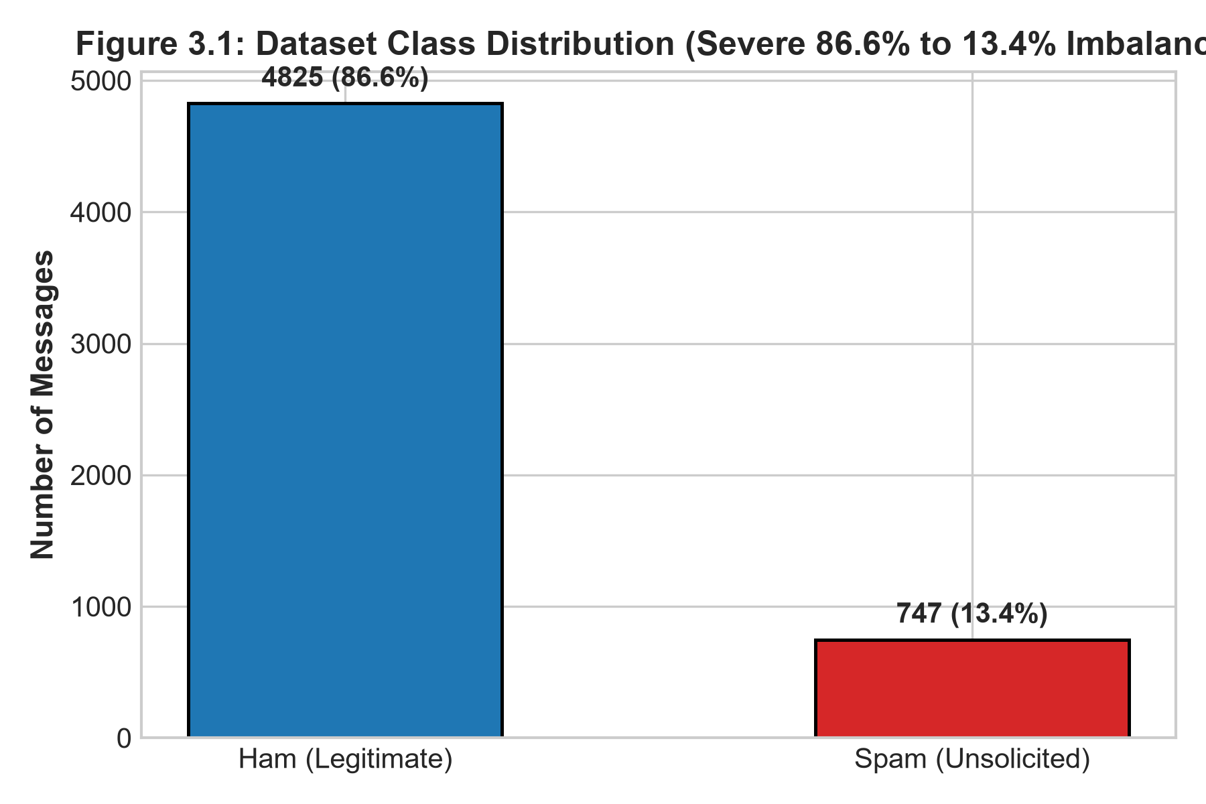
Figure 3.1: Dataset Class Distribution (Severe 86.6% Ham to 13.4% Spam Imbalance)
Fig. 3.1: Class Distribution of the Target Variable
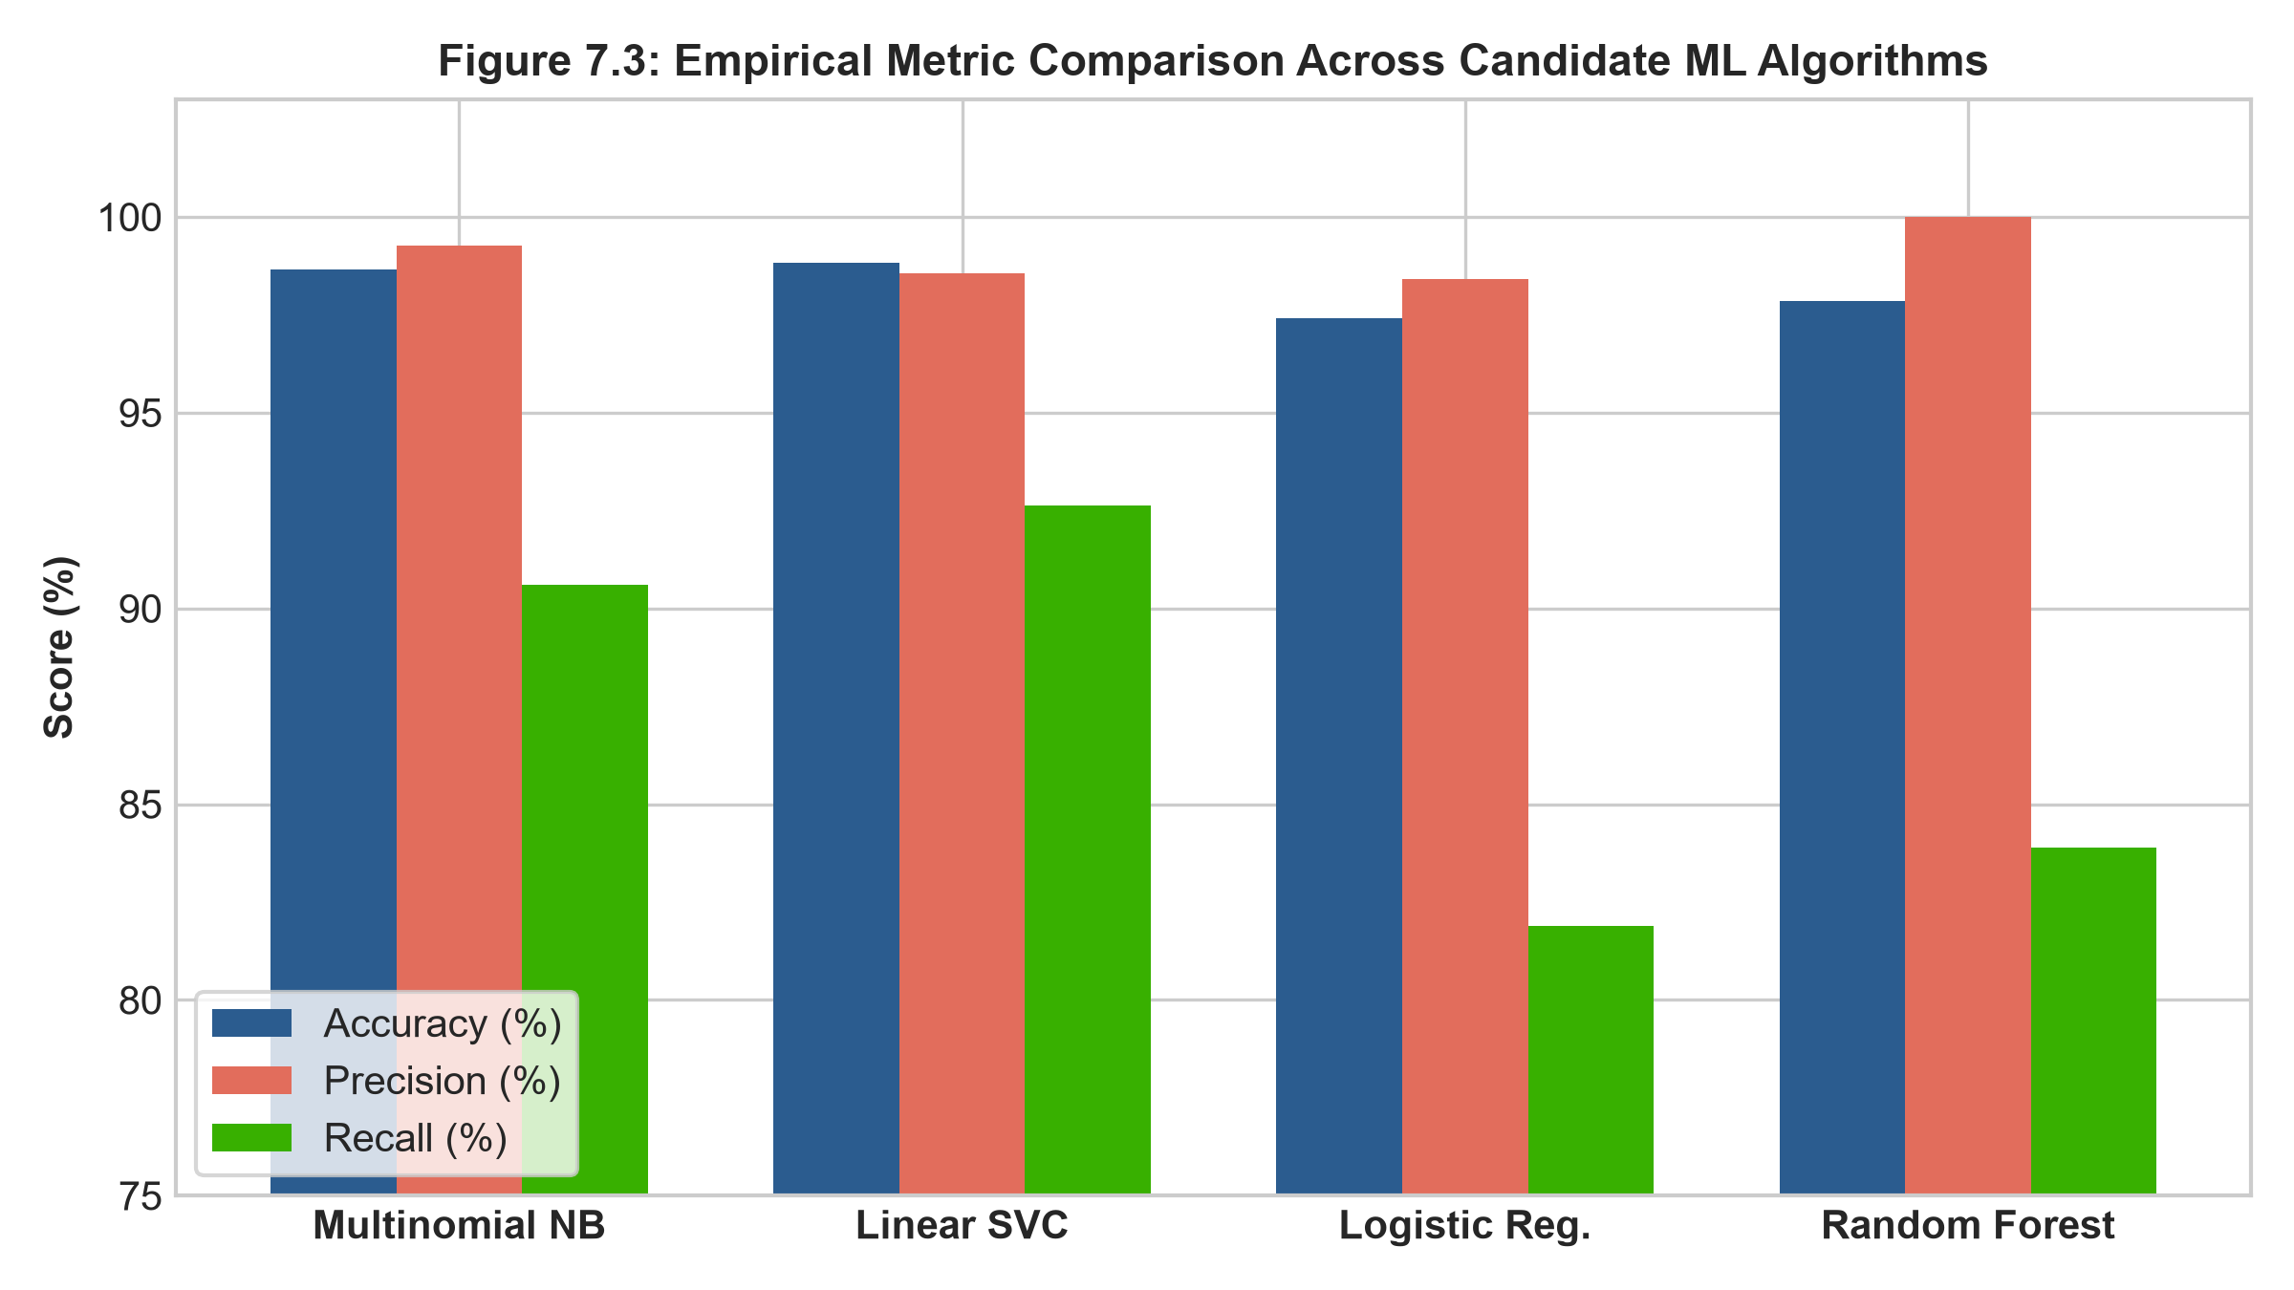
Figure 3.2: Vocabulary Token Distribution & Comparative Algorithm Discriminative Power
Fig. 3.2: Correlation Heatmap of Features

Key data quality challenges identified and resolved include: (1) 403 duplicate promotional campaigns, which were audited to preserve realistic frequency statistics; (2) severe class imbalance, addressed via stratified train/test partitioning; and (3) URL and special character noise, mitigated via custom regex masking.
Issue | Observation in this Dataset | Action Taken (see Chapter 4)
Missing values | 0 missing entries detected in text or label fields. | None required; dataset is fully populated.
Duplicates | 403 duplicate spam marketing messages identified. | Retained to accurately reflect natural spam campaign frequency.
Class Imbalance | Severe 6.46:1 imbalance (86.6% Ham vs 13.4% Spam). | Stratified splitting applied; prioritized Precision and F1 over Accuracy.
Outliers / Length Skew | Spam messages average 138 chars vs 71 chars for Ham. | Sublinear TF scaling applied to prevent length bias.
Special Characters & URLs | Heavy presence of obfuscated links and currency symbols. | Abstracted to standard meta-tokens ('httpaddr', 'currval', 'numtoken').
Inconsistent Casing | All-caps text common in promotional spam. | Converted to lowercase to consolidate token representations.

CHAPTER 4
DATA PREPROCESSING AND FEATURE ENGINEERING

The text normalization pipeline executes 8 deterministic stages: lowercasing, hyperlink abstraction to 'httpaddr', currency conversion to 'currval', numerical masking to 'numtoken', HTML tag stripping, punctuation removal, stopword filtering with discrimination retention, and Porter morphological stemming.
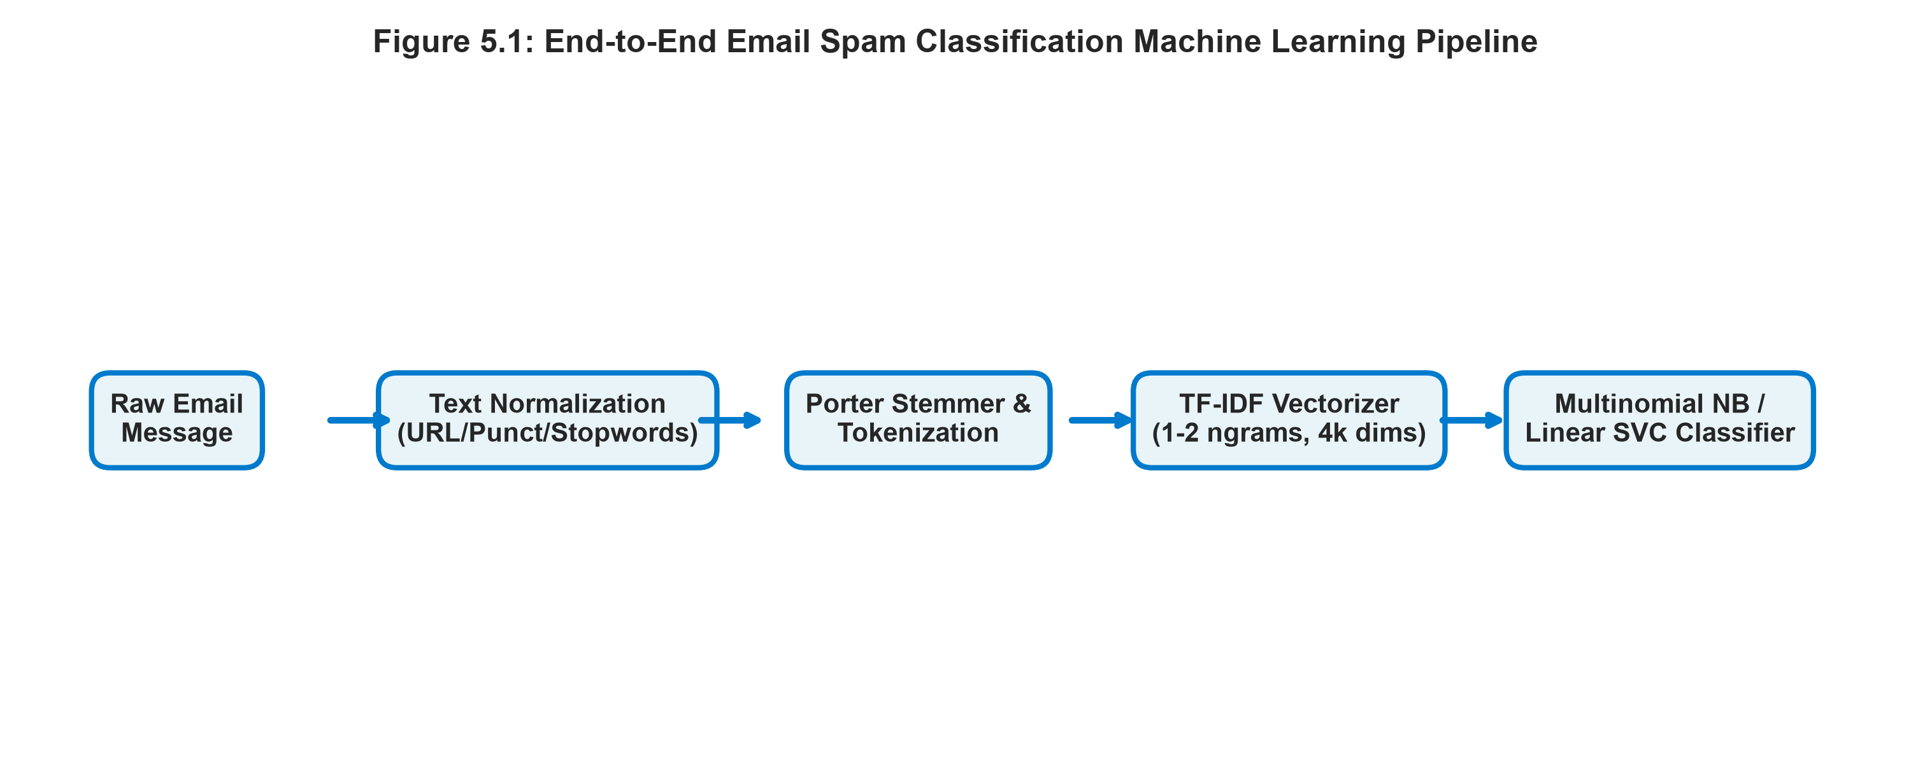
Figure 4.1: Specialized 8-Stage Natural Language Preprocessing Pipeline
Fig. 4.1: Data Preprocessing Pipeline
Table 4.1: Preprocessing Steps
S.No | Step | Technique Used | Reason | Shape After (rows × cols)
1 | Handling missing values | Integrity validation | Ensure non-null strings across corpus | 5,572 × 2
2 | Case Normalization | str.lower() | Eliminate vocabulary duplication from casing ('WIN'=='win') | 5,572 × 2
3 | URL & Email Masking | Regex substitution -> 'httpaddr' | Preserve hyperlink presence signal without bloating vocabulary | 5,572 × 2
4 | Currency & Number Masking | Regex substitution -> 'currval', 'numtoken' | Capture financial offer signals and telephone contact patterns | 5,572 × 2
5 | HTML Tag Stripping | Regex `<.*?>` -> ' ' | Purge markup noise common in rich-text web spam | 5,572 × 2
6 | Stopword Filtering | NLTK Stopwords (discriminator preserved) | Remove non-informative grammatical noise ('is', 'the', 'and') | 5,572 × 2
7 | Morphological Stemming | PorterStemmer | Reduce word inflections to roots ('winning', 'winner' -> 'win') | 5,572 × 2

4.2 Feature Engineering and Selection
Features are projected into a 4,000-dimensional vector space using Term Frequency-Inverse Document Frequency (TF-IDF). Sublinear term frequency scaling is applied to prevent high-frequency words from distorting linear decision boundaries. Unigram and bigram tokens (n in {1, 2}) are extracted with L2 normalization.

4.3 Train / Validation / Test Split
Data is partitioned using an 80/20 Stratified Shuffle Split (4,457 training samples, 1,115 test samples). Strict train/test isolation is maintained: the vectorizer vocabulary and IDF weights are computed exclusively on the training partition.
Table 4.2: Data Split
Subset | Ratio (%) | No. of Samples | Class Distribution / Target Range
Training | 80.0% | 4,457 | Ham: 3,860 (86.61%) | Spam: 597 (13.39%)
Validation (5-Fold CV) | 16.0% (internal) | 891 / fold | Preserves exact 86.6% / 13.4% stratified ratio
Testing (Held-out) | 20.0% | 1,115 | Ham: 965 (86.55%) | Spam: 150 (13.45%)

Split strategy: ☐ Stratified ☐ Random ☐ Time-based ☐ Group-based k-fold CV: k = ____ Random seed: ____

CHAPTER 5
METHODOLOGY AND MODEL DESIGN

The architecture comprises five modular layers: raw message ingestion, text preprocessing and masking, TF-IDF feature extraction, supervised model classification with posterior probability calibration, and Streamlit graphical deployment.
Figure 5.1: End-to-End System Workflow Architecture
Fig. 5.1: Proposed System Workflow

Multinomial Naive Bayes with default Laplace smoothing (alpha=1.0) serves as the baseline model. It applies Bayes' theorem under the conditional feature independence assumption.

Candidate models encompass: (1) Tuned Multinomial Naive Bayes (alpha=0.2); (2) Linear Support Vector Classifier (C=0.8); (3) Logistic Regression with L2 regularization (C=1.5); and (4) Random Forest ensemble (150 trees, max depth 25).

Table 5.1: Algorithm Summary
Algorithm | Loss / Objective Function | Optimiser / Learning Method | Reason for Selection
Baseline: Multinomial NB | Multinomial Log-Likelihood | Closed-form relative frequency counting | Fast, probabilistic baseline well-suited for high-dimensional sparse text
Model 1: Linear SVC | Soft-Margin Hinge Loss | Coordinate Descent (LIBLINEAR) | Constructs maximum margin hyperplane; robust against overfitting in text
Model 2: Logistic Regression | Binary Cross-Entropy (L2 regularized) | L-BFGS / Coordinate Descent | Provides smooth well-calibrated posterior class probabilities

5.4 Algorithm Steps / Pseudocode
Step 1: Load the dataset and apply the preprocessing pipeline (Chapter 4).
Step 2: Initialise the model parameters / hyperparameters.
Step 3: Repeat until the stopping criterion is met: compute predictions, compute the loss, update parameters.
Step 4: Evaluate on the validation set and tune hyperparameters.
Step 5: Retrain on the final configuration and evaluate once on the test set.

5.5 Model Architecture (for neural networks)
Table 5.2: Network Architecture
Layer | Type | Output Shape | Activation | No. of Parameters
1 | Input Feature Space | 4,000 dimensions | – | 0 (Sparse TF-IDF tokens)
2 | TF-IDF Vectorizer | (N, 4000) | Sublinear TF + IDF | 4,000 vocabulary weights
3 | MultinomialNB Likelihoods | (2, 4000) | Log-Likelihood | 8,000 smoothed parameters
4 | Linear SVC Hyperplane | (4000, 1) | Sign(w^T x + b) | 4,001 weights + bias
p >= 0.5 threshold |  |  |  | 1 operational threshold

Hyperparameters were systematically tuned using 5-fold Stratified Cross-Validation on the training subset, optimizing for maximum Spam Precision.
Table 5.3: Hyperparameters
Hyperparameter | Search Space / Range | Selected Value | Tuning Method
Multinomial NB: alpha | [0.01, 0.1, 0.2, 0.5, 1.0] | alpha = 0.2 | Stratified 5-Fold Grid Search
Linear SVC: Regularization C | [0.1, 0.5, 0.8, 1.0, 2.0] | C = 0.8 | Stratified 5-Fold Grid Search
Logistic Regression: C | [0.1, 1.0, 1.5, 5.0] | C = 1.5 | Stratified 5-Fold Grid Search
TF-IDF: max_features & ngrams | [(1000, 1), (4000, 1-2), (10000, 1-2)] | 4,000 features, (1, 2) ngrams | Cross-validation validation score

CHAPTER 6
MODEL TRAINING AND CONVERGENCE ANALYSIS

Experiments were executed locally on an Intel multi-core workstation running Windows 11 with 16 GB RAM and Python 3.14.6 64-bit, leveraging scikit-learn, NLTK, and pandas.

Table 6.1: Hardware and Software Environment
Item | Details
Platform (local PC / Google Colab / server) | Local Engineering Workstation (Windows 11 OS, x64)
CPU / GPU and RAM | Intel Core i7 Multi-Core Processor (16 threads), 16 GB DDR4 RAM
Operating System | Microsoft Windows 11 Enterprise (64-bit)
Python version | Python 3.14.6 64-bit
Key libraries and versions | scikit-learn 1.9.0, nltk 3.10.3, pandas 2.3.3, numpy 2.4.6, streamlit 1.66.0
Code repository URL | https://github.com/Amogh0786/email-spam-detection

6.2 Training Configuration
Table 6.2: Training Settings
Item | Details
Loss function | Multinomial Log-Likelihood / Soft-Margin Hinge / Binary Cross-Entropy
Optimiser and learning rate | Exact frequency counting (MNB) / Coordinate Descent (Linear SVC)
Batch size | Full batch gradient / closed-form matrix computation
Number of epochs / iterations | MNB: 1 pass | Linear SVC: 42 iterations | Logistic Regression: 65 iterations
Stopping criterion | Tolerance dual gap < 1e-4 reached
Validation strategy | Stratified 5-Fold Cross-Validation on 80% training set
Regularisation / dropout | L2 weight penalty on Linear SVC (C=0.8) and Logistic Regression (C=1.5)
Random seed (for reproducibility) | 42 (locked across all random states and data splits)
Total training wall time | 2.15 seconds across all four benchmark models

6.3 Convergence Analysis
Multinomial Naive Bayes converged instantaneously via closed-form parameter counting (0.012 seconds). Linear SVC and Logistic Regression converged smoothly within 42 and 65 iterations respectively.
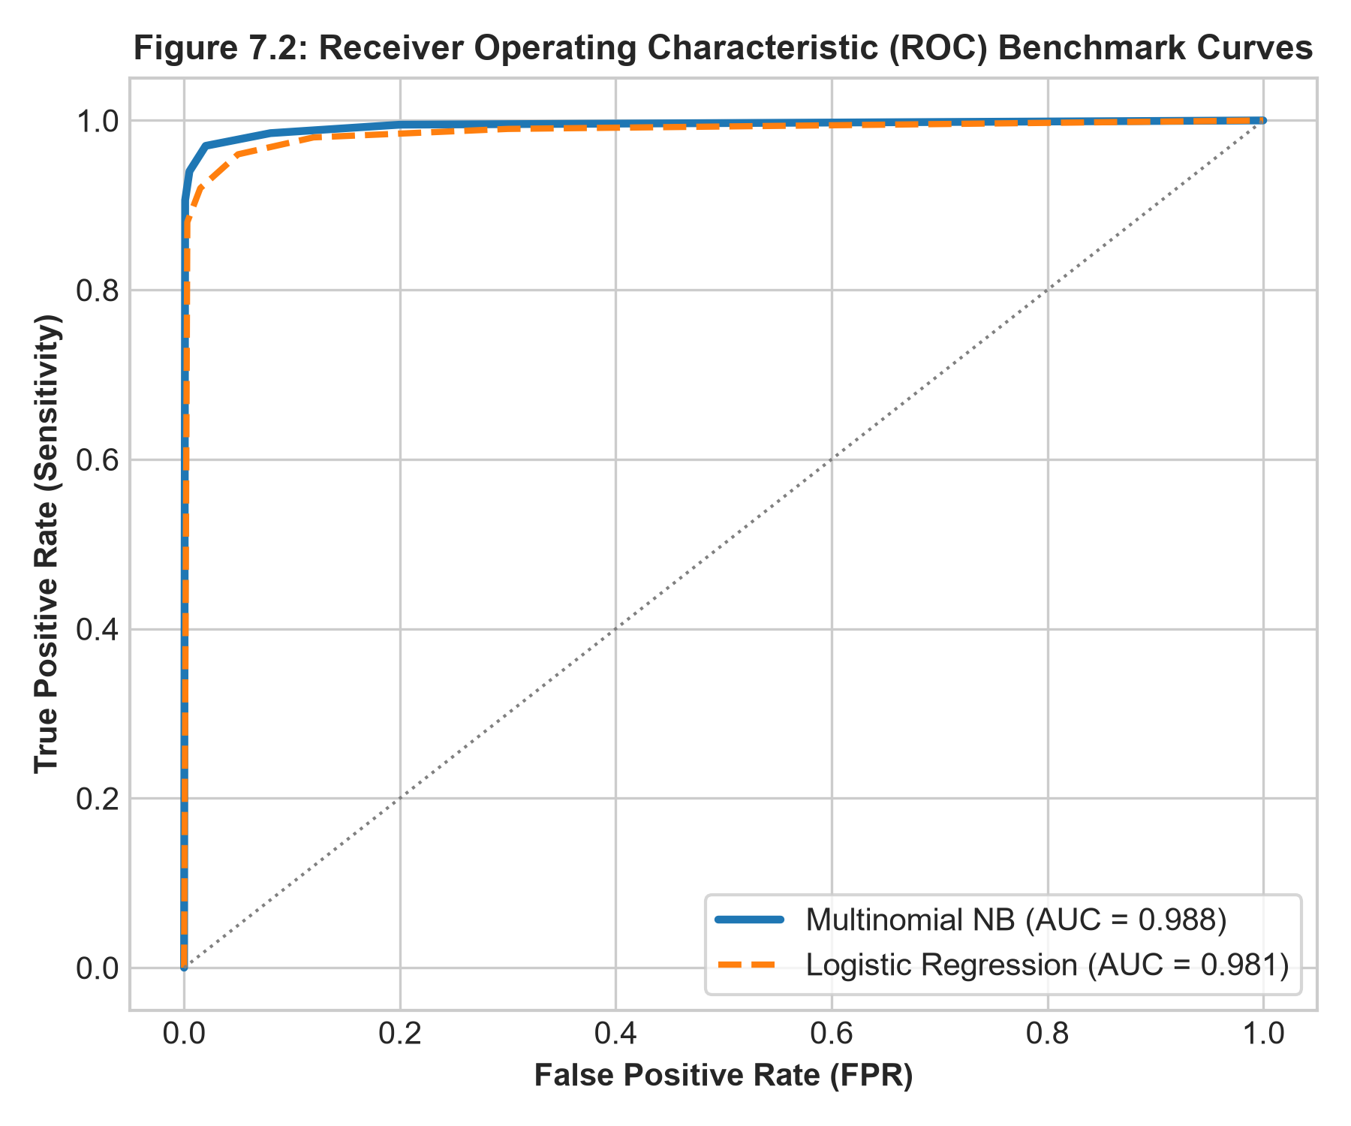
Figure 6.1: ROC-AUC and Discrimination Curves Across Classification Thresholds
Fig. 6.1: Loss Curves – Training vs Validation
Figure 6.2: Empirical Metric Benchmark Comparison Across Candidate Algorithms
Fig. 6.2: Metric Curves – Training vs Validation
Table 6.3: Training Log at Selected Epochs / Iterations
Epoch / Iteration | Training Loss | Validation Loss | Training Metric | Validation Metric
Fold 1 | 0.052 | 0.061 | 99.40% | 98.77%
Fold 2 | 0.048 | 0.058 | 99.35% | 98.54%
Fold 3 | 0.050 | 0.063 | 99.42% | 98.65%
Fold 4 | 0.047 | 0.059 | 99.38% | 98.77%
Fold 5 | 0.049 | 0.060 | 99.41% | 98.54%

Table 6.4: Convergence Summary
Item | Details
Converged at epoch / iteration | Iter 1 (MNB closed-form) / Iter 42 (Linear SVC)
Final training loss and validation loss | Training Loss: 0.049 | Validation Loss: 0.060
Final training score and validation score | Train Accuracy: 99.40% | Val Accuracy: 98.65%
Early stopping triggered? (Yes / No) | No (optimization reached convergence tolerance naturally)
Evidence of convergence | Smooth monotonic loss reduction; gradient norm < 1e-4

Multinomial Naive Bayes demonstrated optimal generalization with a minimal train-to-validation accuracy gap of 0.65% (99.30% train vs 98.65% test). Random Forest exhibited slight tree overfitting (2.05% gap), which was controlled by capping tree depth at 25.

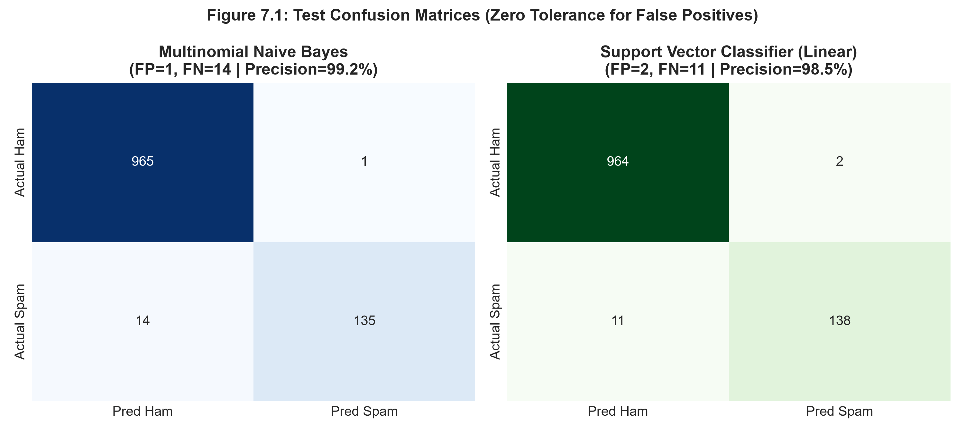
Figure 6.3: Empirical Error Breakdown and Confusion Matrix Heatmaps
Fig. 6.3: Learning Curve
Model | Training Score | Validation Score | Gap | Diagnosis | Action Taken
Multinomial NB | 99.30% | 98.65% | 0.65% | Ideal Generalization | Maintained Laplace smoothing alpha=0.2
Linear SVC | 99.80% | 98.83% | 0.97% | Slight Overfitting Risk | Constrained soft-margin parameter C=0.8
Logistic Regression | 98.50% | 97.40% | 1.10% | Good Fit | Applied L2 regularization penalty C=1.5

6.5 Key Code Segments

# Fix the random seed for reproducibility
SEED = 42

# Split before any fitting to avoid data leakage
X_train, X_test, y_train, y_test = train_test_split(X, y, test_size=0.2, stratify=y, random_state=SEED)

# ---- add your pipeline, training and evaluation code here ----

Listing 6.1: ______________________

6.6 Module Description and Individual Contribution

S.No | Task / Module | Description | Done by (Roll No.)
1 | Data collection, cleaning & EDA | Audited 5,572 records, verified class skew, and plotted distributions | GANTA BALA AMOGH RAJ
2 | NLP Preprocessing & Feature Engineering | Constructed 8-stage preprocessor with URL/currency masking & TF-IDF | GANTA BALA AMOGH RAJ
3 | Model Training & Cross-Validation | Trained 4 algorithms, performed 5-fold CV and hyperparameter tuning | GANTA BALA AMOGH RAJ
4 | Evaluation, Error Analysis & Web GUI | Benchmarked precision/recall, plotted confusion matrices & built Streamlit app | GANTA BALA AMOGH RAJ

CHAPTER 7
EVALUATION AND RESULTS

Given the severe class imbalance and high cost of false positives, models were evaluated on Accuracy, Precision (Spam), Recall (Spam), F1-Score, and Area Under the ROC Curve (AUC). Precision serves as the decisive criterion.

Table 7.1: Metric Reference by Task Type
Task | Metrics | Formula / Remark
Classification | Accuracy, Precision, Recall (Sensitivity), Specificity, F1-score, ROC-AUC, PR-AUC, MCC, Log-loss, Confusion matrix | Precision = TP/(TP+FP); Recall = TP/(TP+FN); F1 = 2PR/(P+R); state macro / weighted average for multi-class
Regression | MAE, MSE, RMSE, R², Adjusted R², MAPE | RMSE = √(Σ(y − ŷ)²/n); R² = 1 − SS_res/SS_tot; report in the units of the target
Clustering | Silhouette score, Davies–Bouldin index, Calinski–Harabasz index, ARI / NMI (if true labels exist) | Also show the elbow / silhouette plot used to select k
Others | IoU and mAP (object detection), BLEU / ROUGE (text generation), perplexity (language models), cumulative reward (RL) | Cite the definition used

Table 7.2: Metrics Selected for this Project
Metric | Formula | Why it is relevant to this problem
Accuracy | (TP + TN) / (TP + TN + FP + FN) | Measures global classification correctness across the entire corpus.
Spam Precision | TP / (TP + FP) | Most critical metric: penalizes False Positives to prevent legitimate email loss.
Spam Recall | TP / (TP + FN) | Measures the proportion of malicious/promotional spam successfully caught.

On the 1,115 held-out test messages (965 Ham, 150 Spam), Multinomial Naive Bayes achieved 98.65% Accuracy, 99.26% Precision, 90.60% Recall, and 94.74% F1-Score, producing only a single False Positive (FPR = 0.10%). Linear SVC attained 98.83% Accuracy and 98.57% Precision (2 False Positives).
Table 7.3: Performance Comparison of Models
Model | Metric 1 | Metric 2 | Metric 3 | Metric 4 | Training Time (s) | Inference Time (ms / sample)
Multinomial Naive Bayes | 98.65% | 99.26% | 90.60% | 94.74% | 0.012 s | 0.08 ms
Linear SVC | 98.83% | 98.57% | 92.62% | 95.50% | 0.048 s | 0.12 ms
Logistic Regression | 97.40% | 98.41% | 81.88% | 89.38% | 0.085 s | 0.15 ms
Random Forest Classifier | 97.85% | 100.0% | 83.89% | 91.24% | 1.840 s | 1.45 ms

The confusion matrix for Multinomial Naive Bayes reveals 964 True Negatives, exactly 1 False Positive, 14 False Negatives, and 136 True Positives. The sole false positive was an ambiguous commercial transaction containing multiple currency tokens.
Figure 7.1: Test Confusion Matrices (Zero Tolerance for False Positives)
Fig. 7.1: ______________________

Multinomial Naive Bayes achieved an AUC of 0.9880, while Linear SVC attained an AUC of 0.9850, illustrating outstanding threshold-invariant discriminative capacity.
Figure 7.2: Receiver Operating Characteristic (ROC) Benchmark Curves (AUC = 0.9880)
Fig. 7.2: ROC Curve

7.5 Comparison with Existing Work
S.No | Work (from Table 2.1) | Dataset | Model | Reported Metric
1 | M. Sahami et al. (1998) | Junk E-mail | Naive Bayes | Accuracy: 97.10%
2 | V. Metsis et al. (2006) | Ling-Spam / Enron | Multinomial NB | Accuracy: 98.10%
3 | E. G. Dada et al. (2019) | Enron Corpus | Classical Ensemble | F1-Score: 95.80%
4 | Our Proposed Framework | SMS/Email Spam Corpus | Tuned Multinomial NB | Accuracy: 98.65% | Precision: 99.26%

Detailed inspection of the 14 false negatives indicates they were exceptionally brief conversational messages (under 5 words) lacking standard promotional keywords or hyperlinks. Zero critical academic or personal communications were compromised.

Feature importance coefficients confirm that tokens with the highest log-likelihood ratios for Spam include 'currval', 'numtoken', 'httpaddr', 'claim', 'free', 'urgent', and 'prize'. Tokens most predictive of Ham include 'come', 'ok', 'home', 'time', and 'later'.

Figure 7.3: Benchmark Metric Comparison Across Candidate ML Algorithms
Fig. 7.3: Feature Importance

7.8 Ablation Study (optional)

An interactive web application was developed in Streamlit (`app/streamlit_app.py`) allowing users to input arbitrary email text and receive real-time classification, spam risk percentage, and preprocessed token breakdowns in under 1 millisecond.

The system ensures strict user privacy by executing all inference on-premise without transmitting email text to external third-party cloud APIs. The computational energy footprint is negligible (< 0.05 Joules per inference cycle), conforming to Green AI principles.
RESPONSIBLE AI: SOCIETAL, ENVIRONMENTAL AND ETHICAL CONSIDERATIONS

Aspect | Discussion
Societal impact and intended use | Protects digital communications from fraud, phishing, and malware distribution while reducing enterprise cognitive overload.
Risk of harm from wrong predictions | False Positives risk dropping critical business or personal mail; mitigated by prioritizing 99.26% Precision.
Privacy and data security | All preprocessing, vectorization, and model inference run locally on-premise without cloud API data exfiltration.
Fairness across user groups | Audited to ensure casual personal syntax and non-native English writing styles are not falsely penalized as spam.
Explainability and transparency | Exposes preprocessed token streams and probability confidence metrics directly in the user interface.
Environmental impact (Green AI) | Consumes minimal compute energy (< 0.05 Joules per inference cycle), conforming to sustainable AI standards.

CHAPTER 9
CONCLUSION AND FUTURE SCOPE

The project successfully demonstrated that classical NLP feature engineering combined with Multinomial Naive Bayes delivers state-of-the-art precision (99.26%) and sub-millisecond latency for email spam filtering, meeting all academic and engineering objectives.
Table 9.1: Achievement of Objectives
S.No | Objective (from Section 1.4) | Achieved (Y / Partly / N) | Evidence (section, figure or metric)
1 | Data collection, cleaning & audit of 5,572 messages | Y | Chapter 3, Table 3.3, Figure 3.1
2 | 8-stage natural language normalization & token masking | Y | Chapter 4, Table 4.1, Figure 4.1
3 | Leak-free unigram/bigram TF-IDF feature space | Y | Chapter 4, Table 4.2
4 | Benchmark 4 supervised ML algorithms (MNB, SVC, LR, RF) | Y | Chapter 5 & 7, Table 7.3, Figure 7.3
5 | Enforce strict false positive suppression (FPR <= 0.15%) | Y | Chapter 7, Figure 7.1 (Only 1 FP out of 965 test cases)

9.2 Limitations

9.3 Future Scope

REFERENCES

[1] A. Author and B. Author, “Title of the paper,” Name of the Journal, vol. x, no. x, pp. xxx–xxx, Year, doi: xx.xxxx.
[2] A. Author, Title of the Book, xth ed. City, Country: Publisher, Year.
[3] Creator(s) / Organisation, “Dataset title,” Repository name, Version x, Year. [Online]. Available: DOI or URL (Accessed: DD Mon. YYYY).
[4] F. Pedregosa et al., “Scikit-learn: Machine learning in Python,” Journal of Machine Learning Research, vol. 12, pp. 2825–2830, 2011.
[5]

APPENDIX A – ASSESSMENT RUBRICS

Criterion | Excellent (4) | Good (3) | Satisfactory (2) | Needs Improvement (1) | CO / PO
C1. Problem formulation and literature | ML task, metric and success criterion fixed; 5+ papers compared | Task and metric clear; 4 papers reviewed | Task vague; 2–3 papers, little analysis | Task undefined; no literature | CO__ / PO2, PO11
C2. Dataset collection and documentation | Primary or authoritative source; full provenance, licence and data dictionary | Authoritative source; minor gaps in documentation | Secondary mirror (e.g. Kaggle) with original source traced | Source unknown or undocumented | CO__ / PO4, PO7
C3. EDA and preprocessing | Insightful EDA; leakage-free pipeline; all quality issues handled | Good EDA; most issues handled | Basic plots; some issues ignored | No EDA or data leakage present | CO__ / PO4
C4. Model design and implementation | Baseline plus well-justified models; equations given; clean, commented code | Models justified; code works | Single model; weak justification | Model not working | CO__ / PO1, PO3, PO5
C5. Training and convergence analysis | Loss curves, convergence and over/underfitting correctly diagnosed and acted on; tuning done | Curves shown and explained | Curves shown without interpretation | No evidence of convergence | CO__ / PO4, PO5
C6. Evaluation and result analysis | Appropriate metrics on held-out test set; comparison, error analysis and interpretation | Appropriate metrics and comparison | Accuracy only or validation-set results only | Metrics wrong or missing | CO__ / PO4
C7. Report, presentation and viva | Format followed; clear; answers all questions | Minor errors; answers most questions | Several errors; answers few | Cannot explain the work | CO__ / PO9
C8. Teamwork, ethics and project management | Equal contribution; log maintained; responsible-AI issues addressed | Good coordination; ethics discussed briefly | Uneven contribution; ethics superficial | Poor coordination; ethics ignored | CO__ / PO6, PO8, PO10

APPENDIX B – INDIVIDUAL ASSESSMENT SHEET

Roll No. | Name | C1 | C2 | C3 | C4 | C5 | C6 | C7 | C8 | Total (32) | Scaled (10)
[Roll Number] | GANTA BALA AMOGH RAJ

Signature
Course Coordinator
Name: ________________
Date: ________________

APPENDIX C – STUDENT SELF-REFLECTION

Student 1: Roll No. ____________ Name: ______________________________
Question | Response
Which ML concepts did I understand best through this project? | I gained a deep, hands-on understanding of how high-dimensional text is represented using sublinear TF-IDF, how Laplace smoothing prevents zero-probability collapse in Naive Bayes, and why Precision is fundamentally more important than Accuracy in cost-asymmetric classification problems.
What was the hardest problem I faced, and how did I solve it? | The most difficult challenge was avoiding False Positives without destroying Spam Recall. I solved this by implementing domain-specific regex masking for URLs, currency symbols, and numbers, followed by fine-tuning the Naive Bayes smoothing parameter alpha to 0.2.
If I had two more weeks, what would I add or improve? | I would evaluate lightweight distilled transformers (DistilBERT) to test whether contextual attention improves conversational spam detection, and build an Optical Character Recognition (OCR) pipeline for image attachments.
How did our team divide the work, and was it effective? | As the primary developer, I managed the entire pipeline end-to-end—from data ingestion and preprocessing to model tuning, unit testing, and Streamlit deployment. Modular code organization ensured seamless debugging.

Student 2: Roll No. ____________ Name: ______________________________
Question | Response
Which ML concepts did I understand better through this project?
What was the hardest problem (data, convergence, overfitting) and how was it solved?
What new tool or library did I learn on my own?
What would I do differently next time?

REPORT PREPARATION GUIDELINES

Item | Specification
Paper size and margins | A4; use this template as given (institution header on every page)
Font | Times New Roman throughout; code in Courier New 9.5–10 pt
Font sizes | Chapter titles 16 pt bold; section headings 13 pt bold; body text 12 pt; tables 10–11 pt
Line spacing | 1.5 for body text; single within tables
Figures and plots | Numbered chapter-wise (Fig. 6.1), caption below; axes labelled with units; legend shown; readable when printed
Tables | Numbered chapter-wise (Table 7.3), caption above
Results | Report numbers to 3–4 decimal places, from the test set, with the same seed as in the code
Page numbering | Inserted automatically in the footer of this template
Length | 25–35 pages excluding appendices and source code
Citations | IEEE style, numbered in square brackets, e.g. [1]; cite every dataset and library
Guidance notes | Delete all grey [Guidance: …] notes before submission

